**電通二甲微處理器實驗 實驗結報**

|  |  |  |  |
| --- | --- | --- | --- |
| **實驗名稱** | 4x4鍵盤 | | |
| **組別** | 十一 | **組員** | 尤竣賢、蔣毓哲 |

1. **實驗目的**

了解4x4 鍵盤的工作原理

1. 4x4 鍵盤如何接線?

2. 如何使用 Arduino keyboard library?

3. 如何讀取鍵盤的顯示數值?

4. 如何讓七段顯示器顯示鍵盤的輸入值?

1. **實驗步驟**

1.4x4 鍵盤之按鍵值經由串列傳輸，顯示在 PC 上

2.4x4 鍵盤之按鍵值顯示在七段顯示器上

1. **程式碼**

**1.** **#include <Keypad.h>**

**const byte ROWS = 4; // 4 Rows**

**const byte COLS = 4; // 4 Columns**

**char keys[ROWS][COLS] =**

**{**

**{'0', '1', '2', '3'}, {'4','5','6', '7'},**

**{'8', '9', 'A', 'B'}, {'C', 'D', 'E', 'F'}**

**};**

**byte rowPins[ROWS] = {5, 4, 3, 2};**

**byte colPins[COLS] = {9, 8, 7, 6};**

**Keypad keypad = Keypad( makeKeymap(keys), rowPins,colPins, ROWS, COLS );**

**void setup()**

**{**

**Serial.begin(9600);**

**}**

**void loop()**

**{**

**char key = keypad.getKey();**

**if (key != NO_KEY)**

**{**

**Serial.println(key);**

**}**

**}**

**2.** **#include <Keypad.h>**

**#include "SevSeg.h"**

**SevSeg sevseg;**

**const byte ROWS = 4; // 4 Rows**

**const byte COLS = 4; // 4 Columns**

**char keys[ROWS][COLS] =**

**{**

**{'0', '1', '2', '3'}, {'4','5','6', '7'},**

**{'8', '9', 'A', 'B'}, {'C', 'D', 'E', 'F'}**

**};**

**byte rowPins[ROWS] = {5, 4, 3, 2};**

**byte colPins[COLS] = {9, 8, 7, 6};**

**Keypad keypad = Keypad( makeKeymap(keys), rowPins,colPins, ROWS, COLS );**

**void setup()**

**{**

**Serial.begin(9600);**

**byte numDigits = 1;**

**byte digitPins[] = {A2};**

**byte segmentPins[] = {11, 10, A3, A1, A0, 12, 13, A4};**

**sevseg.begin(COMMON_CATHODE, numDigits, digitPins,segmentPins);**

**}**

**void loop()**

**{**

**char key;**

**key = keypad.getKey();**

**int a;**

**if (key != NO_KEY)**

**{**

**if(key >='A' && key <='F')**

**{**

**a = key-'A';**

**}**

**else**

**{**

**a = key-'0';**

**}**

**Serial.println(key);**

**sevseg.setNumber(a,1);**

**sevseg.refreshDisplay();**

**}**

**else**

**{**

**sevseg.refreshDisplay();**

**}**

**}**

1. **實驗結果及分析**

藉由這次實驗利用4x4鍵盤，輸入自ardunio再顯至七段顯示器上也可讀入到電腦內

1. **心得討論**

這次的實驗我們一開始還搞不清楚七段顯示器要怎麼接還現不太好接線會一直掉出來

1. **修正電路圖**

**1.**

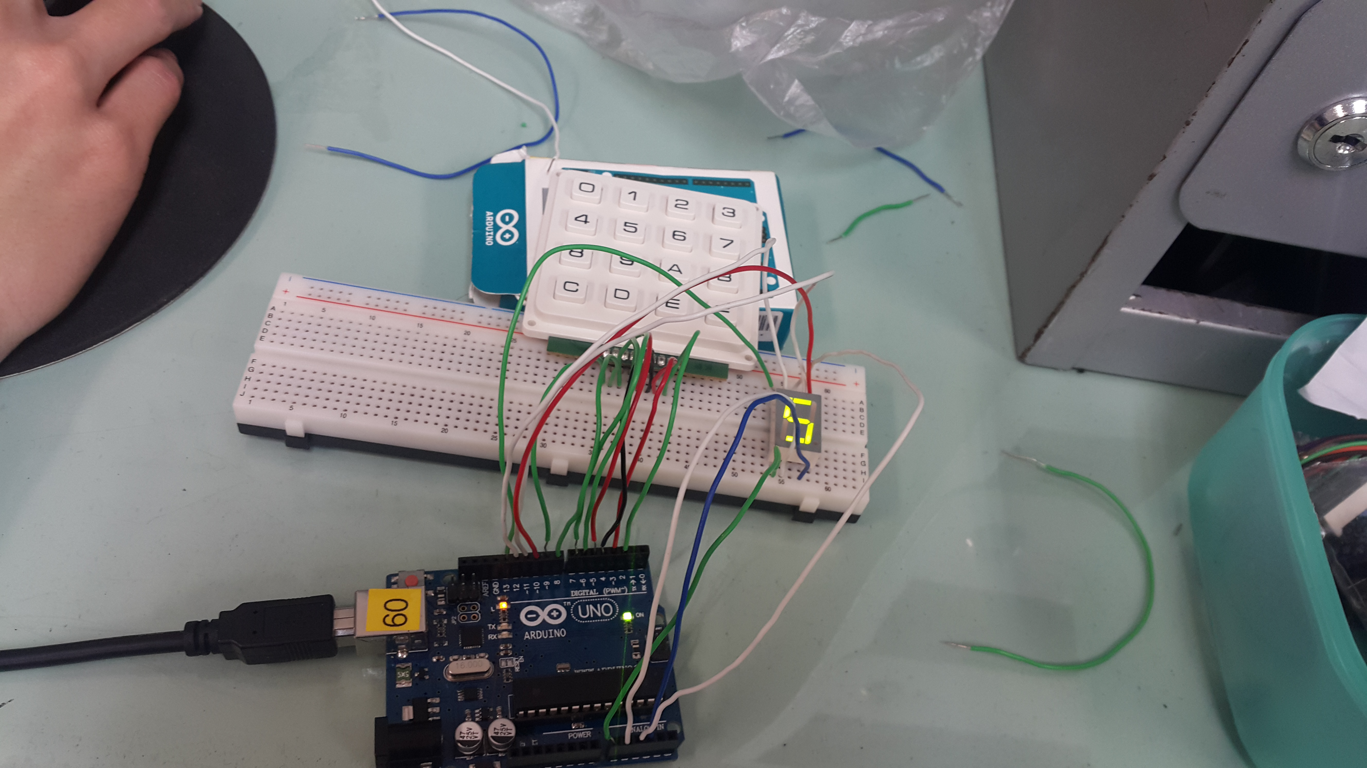

**2.**

**修正程式碼**

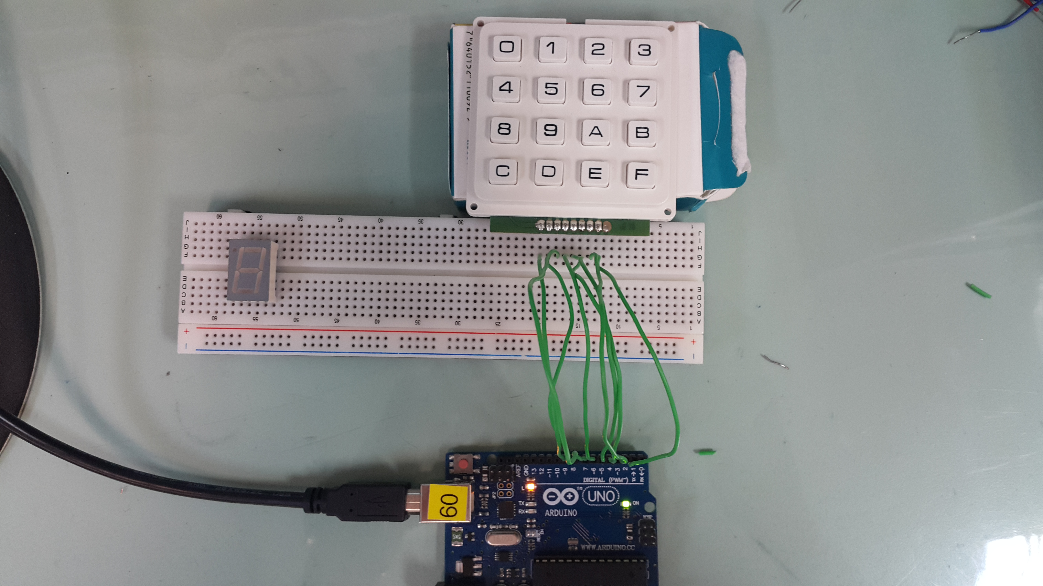

**1.**

